**Screen capture of code coverage:**

**Ordermanagement service:**

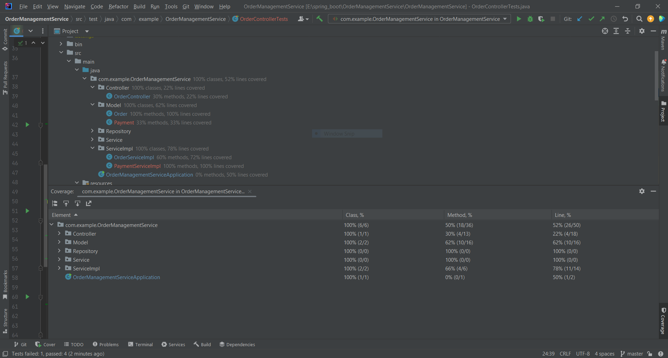

RestaurantSearch service:

